clonning ersilia from github using the command below and it was a success
git clone https://github.com/ersilia-os/ersilia.git
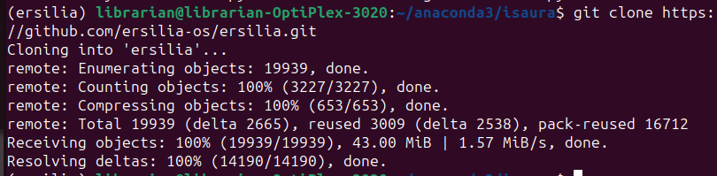

checking ersilia working and it was a success as per attached files using the command
ersilia –help

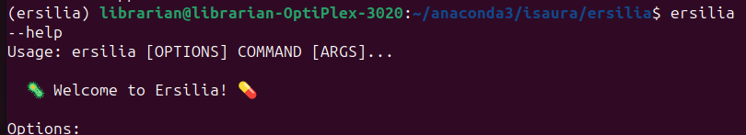
checking ersilia model catalogue after ersilia setup and it was a success as per attached files using the command
ersilia catalog

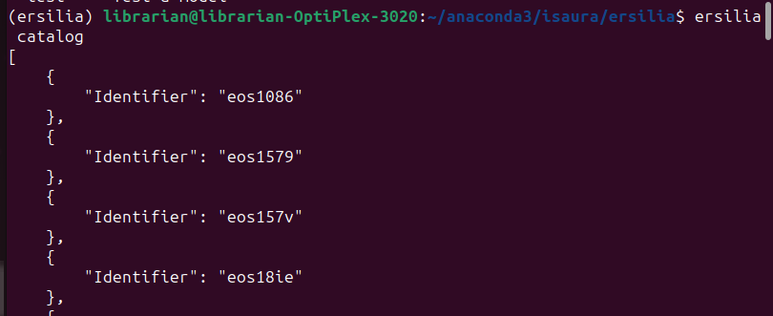
Testing simple model by fetching and serving using the commands, was a success as per screen short
ersilia -v fetch eos3b5e
ersilia serve eos3b5e
ersilia -v api run -i "CCCC"
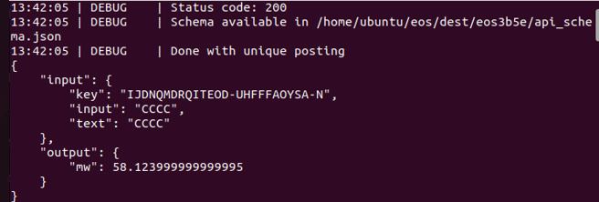

From the results of serving the model, the value of the molecular weight (mw) helps to determine the relationship between reactants and the products of compounds making up the model when reacting. Thus, tell us the amounts of the substances involved in the reaction. With high value of molecular weight, means small amounts of substances are involved in the reaction. Where as low molecular weight meas large amounts of substances are involved in the reaction for a know constant mass of the substances involved in the reaction. In the scenario of this specific model that was tested, the value of molecular weight lies between high and low, means the amount of the substances involved in the reaction were in optimal range.

